**Measurement of Moses 2 Surface**

June 6, 2017

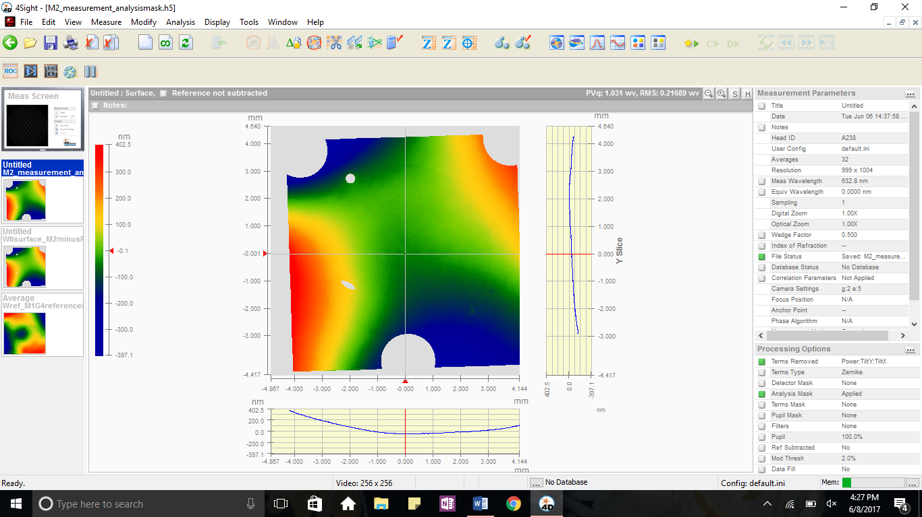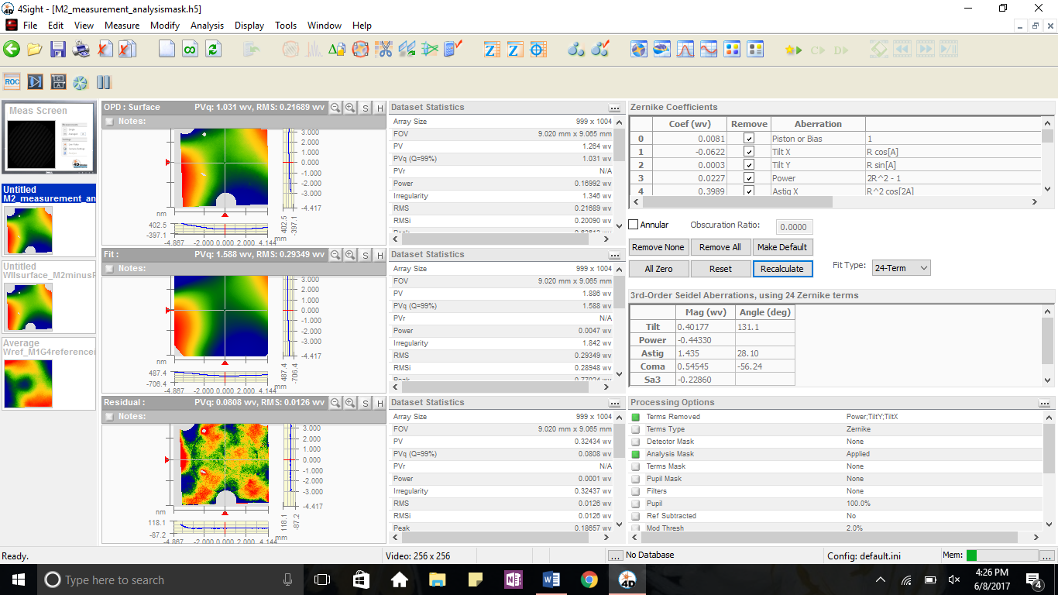

**Measurement of Moses II – WII**

An interferometer image of the Moses 2 primary mirror in its mount. The three large circles are masked bolts holding the mirror to the mount and the grey holes on the image are large dust particles on the surface of the mirror. The Zernike fit is shown on the left:

Astig X 0.3989

Astig Y 0.5961

Coma X 0.1011

Coma Y -0.1512

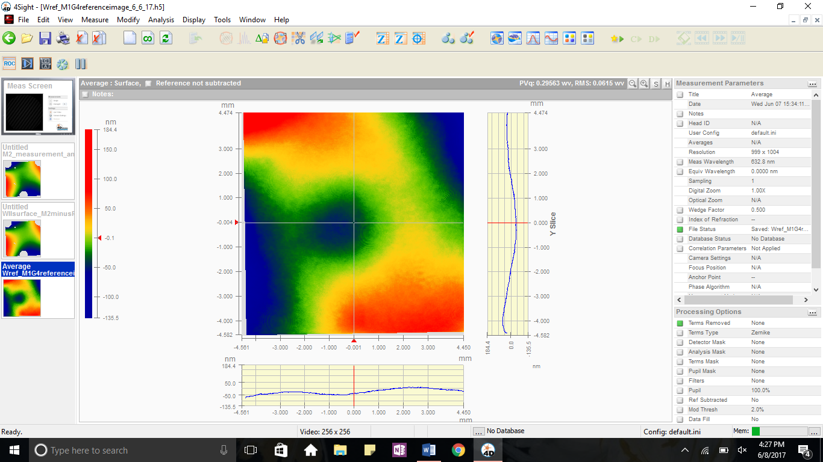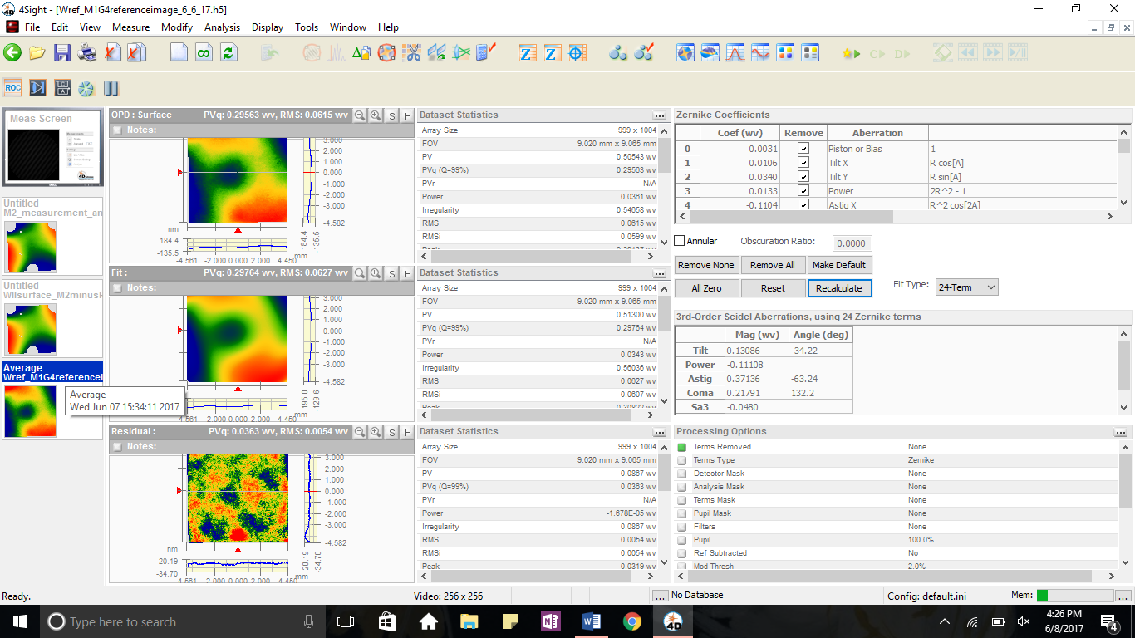

**The Reference Surface – Wref**

The four rotations of Moses 1 primary – 0 degrees, 90 degrees, 180 degrees, and 270 degrees – are averaged to form a reference surface.

Astig X -0.1104

Astig Y -0.1493

Coma X -0.0488

Coma Y 0.0538

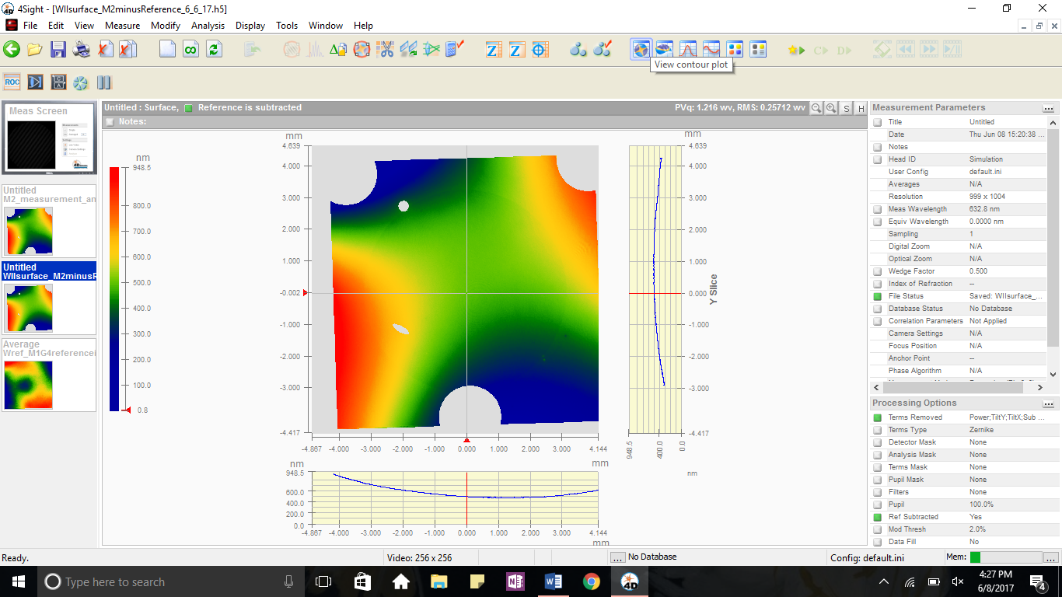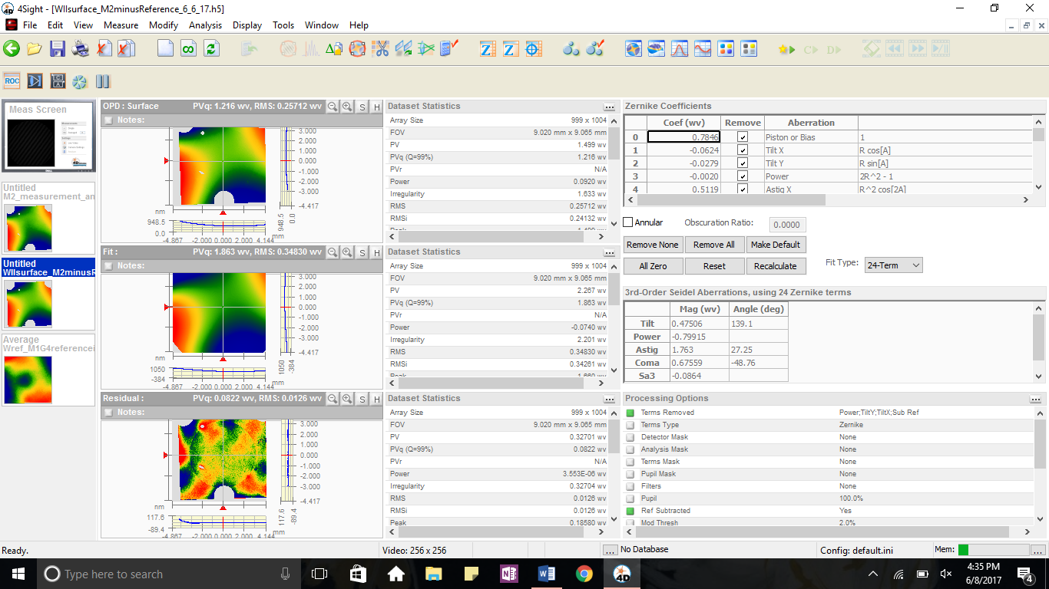

**Surface of Mirror – WIII,Surf**

For this measurement, the Wref reference surface is subtracted from the WII measurement. This gives the shape of the mirrors surface, excluding any aberrations caused by the telescope or interferometer itself.

Astig X 0.5119

Astig Y 0.7177

Coma X 0.1484

Coma Y -0.1694